Market Street. Bldg. 555 California Street, California and Kearny. A 52 storey building

Bank of America, San Francisco, CA Jun 2007 – Apr 2009
Business Analyst
Project: Development of UI for Merrill Edge
The project was to create an intuitive user interface for the Merrill Edge self-directed investment application. The Merrill Edge is a new service from BofA, which provide its customers with a full range of Investment and Banking products and solutions, including brokerage accounts, IRAs, Checking accounts, and CDs. It also provides its customers online access to the intellectual capital of Merrill Lynch, including BofA Merrill Lynch Global Research, market insights and analysis as well as valuable third-party commentary.
Responsibilities:
- Conducted current state analysis and proposed state analysis.
- Elicited Requirements and documented BRD and FSD.
- Provided project management controls, project plans, timeline schedules, and project progress reports
- Provided business requirements within Waterfall software development environment.
- Extensively involved in creating screen mock-ups using Dreamweaver.
- Created and maintained Requirement Traceability Matrix RTM.
- Closely interacted with designers and software developers to help them understand application functionality and navigational flow.
- Worked with QA team to create and execute test cases.
- Facilitated the use of tools such as, RSS feeds and Wikis.
- Wrote advanced SQL queries to test the database backend.
- Used SQL queries to extract data from different databases including testing and production for data validation and data analysis.
Environment: Java, ClearQuest, HTML, SQL, Oracle 9i, MS Project, MS Visio, MS Office, Quality Center 9.0, Windows X

Not there before!

Add on to the existing online banking! Make it available to online banking infrastructure. So, customers can tap into the vast knowledge base of Merrill Lynch’s investment managers.

Bank of America, San Francisco, CA Jun 2007 – Apr 2009
Business Analyst
Project: Development of UI for Merrill Edge
The project was to create an intuitive user interface for the Merrill Edge self-directed investment application. The Merrill Edge is a new service from BofA, which provide its customers with a full range of Investment and Banking products and solutions, including brokerage accounts, IRAs, Checking accounts, and CDs. It also provides its customers online access to the intellectual capital of Merrill Lynch, including BofA Merrill Lynch Global Research, market insights and analysis as well as valuable third-party commentary.
Responsibilities:
- Conducted current state analysis and proposed state analysis.
- Elicited Requirements and documented BRD and FSD.
- Provided project management controls, project plans, timeline schedules, and project progress reports
- Provided business requirements within Waterfall software development environment.
- Extensively involved in creating screen mock-ups using Dreamweaver.
- Created and maintained Requirement Traceability Matrix RTM.
- Closely interacted with designers and software developers to help them understand application functionality and navigational flow.
- Worked with QA team to create and execute test cases.
- Facilitated the use of tools such as, RSS feeds and Wikis.
- Wrote advanced SQL queries to test the database backend.
- Used SQL queries to extract data from different databases including testing and production for data validation and data analysis.
Environment: Java, ClearQuest, HTML, SQL, Oracle 9i, MS Project, MS Visio, MS Office, Quality Center 9.0, Windows X

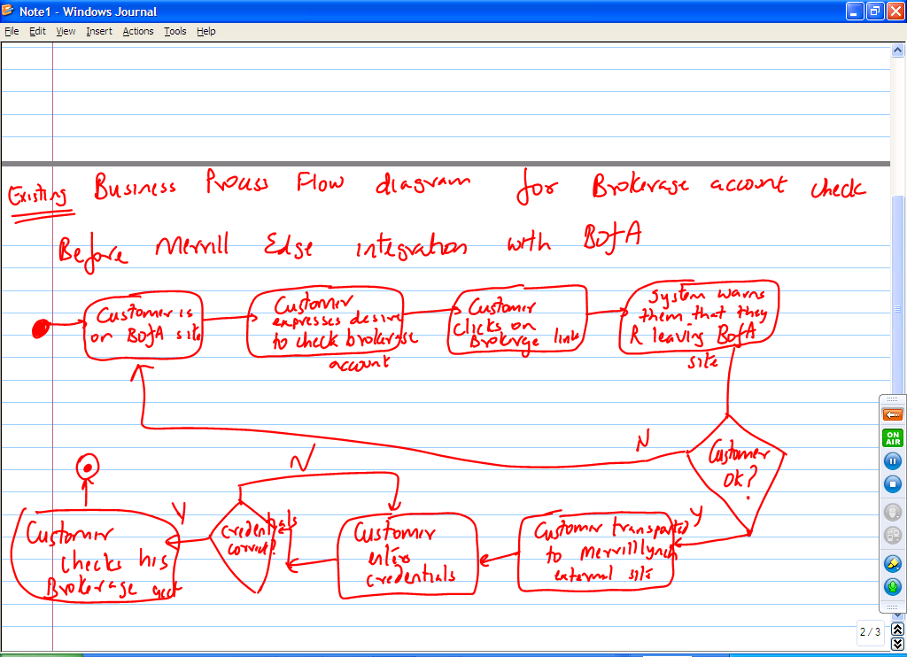

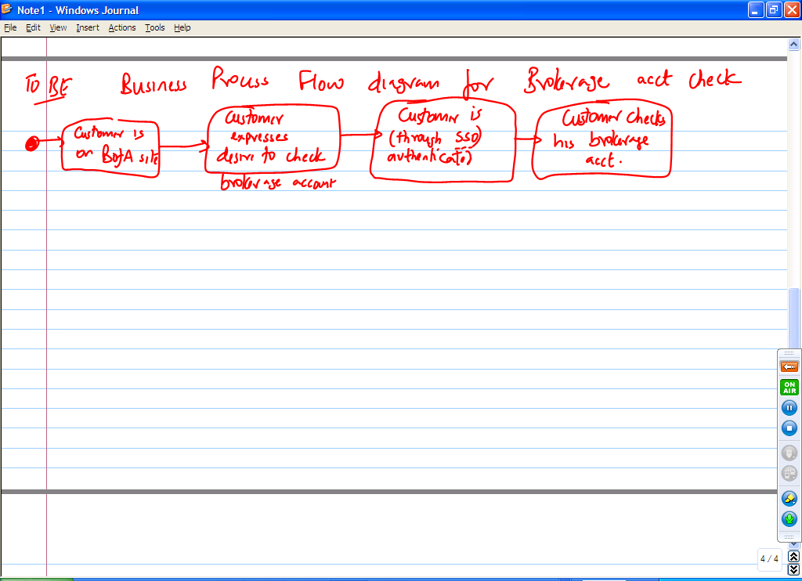
Tell me the difference between business requirements and functional requirements

Biz requirements are high level statements of business needs and wants. Functional Requirements are further fleshing out of the business needs and wants through Use Cases. E.g., for my MerrillEdge project, the business requirements will be:
- Customers should be seamlessly integrated between our 2 lines of business
  - Customers should be able to check their checking, savings and brokerage accounts without having to identify themselves to the system again
- System should have time out security built in so as to avoid security threats
- Customers should have 24X7 access to their customer requirement
- Customers should be able to trade securities
- Customers should have the option to transfer funds between their regular DDA accounts and brokerage accounts

Use cases (Functional requirements) will be
- Login to the site
- Sell securities (directly derived from BR 4)
- Buy securities (directly derived from BR 4)
- Transfer funds

